How to setup D1201 as a wireless router-Dynamic IP
Model number: D1201
This article will guide you how to setup Tenda D1201 IPOE of ETH link type and the steps as below.
Part 1: Connect the devices
Part 2: Configure your computer
Part 3: Setup the router
Part 4: Check whether you can access internet

When IPOE of ETH link type mode is enabled, D1201 works as a wireless router.
- Connect the Ethernet cable with the WAN port of D1201, and then connect your computer with LAN port of D1201 by a cable.
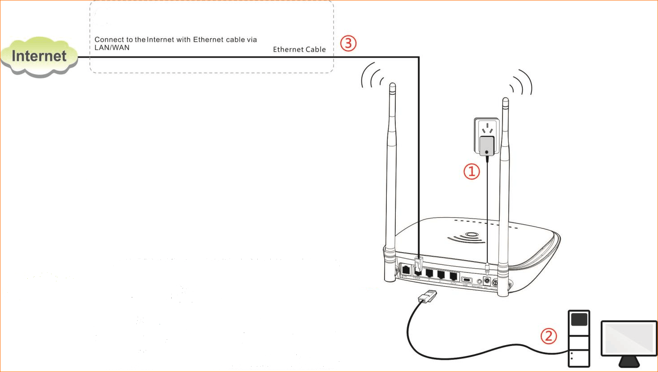
1. Click on Network Connection Icon on the system bar, then click on Open Network and Sharing Center.
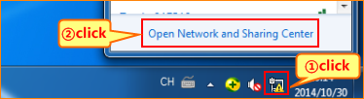
2. Click on Change adapter settings.
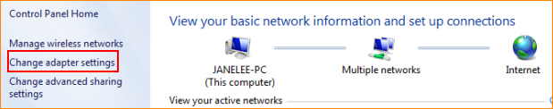
3. Right click on Local Area Connection, then choose the Properties option.
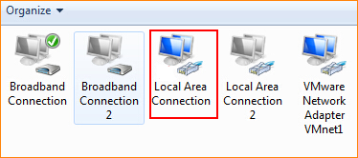
4. Double click on Internet Protocol Version 4(TCP/IPv4).
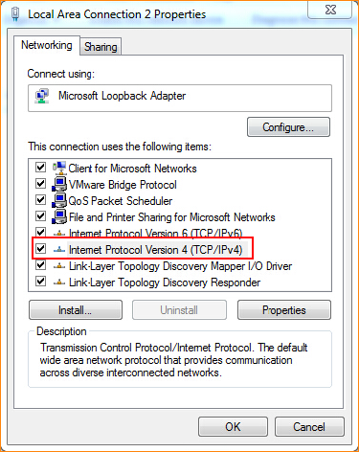
5. Choose Obtain an IP address automatically and Obtain DNS server address automatically and then click OK.

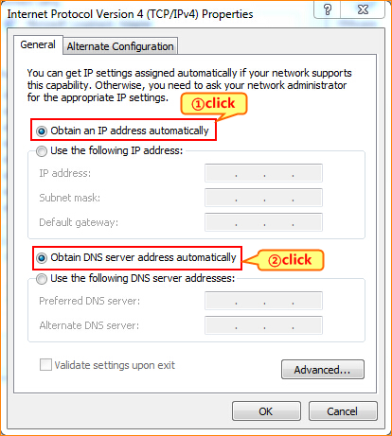
6 Also click on OK on the first Local Connection Properties window.
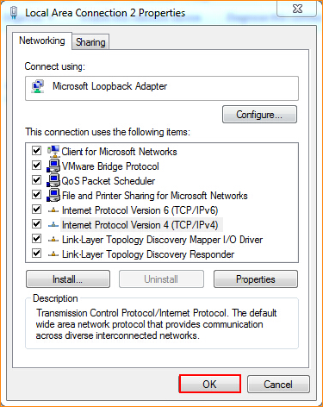
3.1 Open a browser then type 192.168.1.1 in the Address bar, click on Enter.
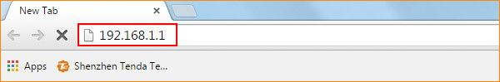
3.2 Choose ETH option, choose connection type as IPOE, and then choose address mode is Dynamic IP.
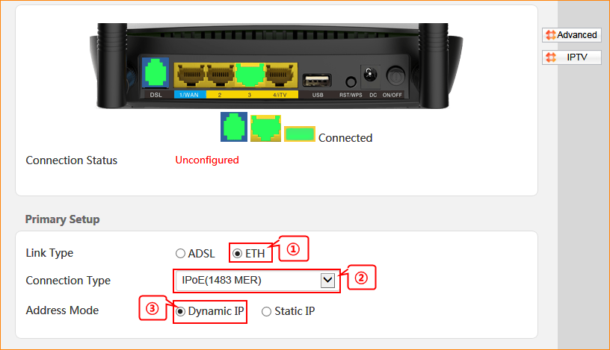

3.3 Change 2.4G/5G wireless SSID and wireless password as you want, and then click OK to save all the settings.
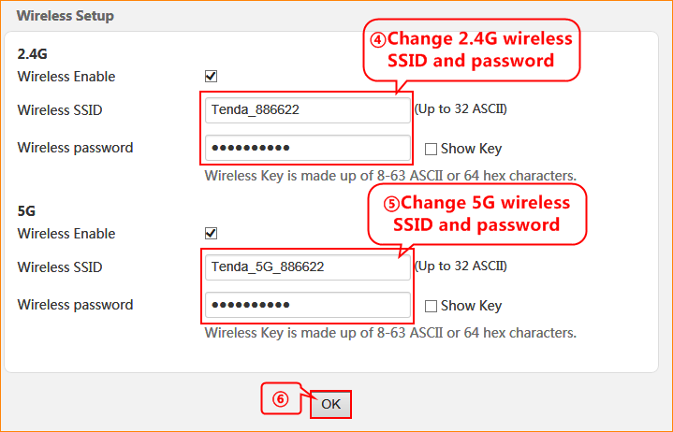

4.1 If connection status shows Connected that means you can access internet, please check.

